Predicting Building-Level Flood Risk by Analysis Comparison of Multi-Layer Perceptron and Bayesian Logistic Regression
Jiada Li, Lang Shao

Introduction and Literature Review

Problem Statement
Flooding is one of the most costliest natural disasters in the US, it has causing billions of dollars in damage annually. The Federal Emergency Management Agency (FEMA) utilizes Flood Insurance Rate Maps to categorize areas by flood risk. And these categorizations, known as FIRM zones, distinguish between high-risk areas (VE, AE, A, AO, AH) and low-risk areas (Area X). However, a critical limitation of these maps is that they rely almost exclusively on macro-level topographic and hydrological data, so they are largely ignoring the specific physical characteristics of individual structures. Consequently, two houses located within the exact same flood zone can possess drastically different true vulnerabilities depending on micro-level factors such as foundation height or construction material…
Our project aims to address this critical gap. So, by leveraging detailed structural data from the National Structure Inventory (NSI), we model flood risk at the individual building level. Specifically, we implement and compare a Multilayer Perceptron (MLP) and a Bayesian Logistic Regression model to predict whether a building falls into a high-risk or low-risk flood zone. This comparison can allow us to evaluate the trade-off between the complex, non-linear pattern recognition of the MLP and the probabilistic, interpretable inference provided by the Bayesian approach, ultimately shifting the paradigm from geospatial area-mapping to structural vulnerability classification.

Refined Literature Review
The methodology we used is informed by four key prior studies. Demissie et al. (2024) has provided a foundational approach, utilize machine learning algorithms to classify flood susceptibility in Kansas based on 13 environmental features. Their models achieved high accuracy scores (0.82–0.97), identifying elevation and distance from water as the most crucial predictors. Our project adapts this rationale by substituting terrain elevation with building-specific ground_elv and found_ht features from the NSI dataset. Furthermore, Demissie et al. emphasize the importance of robust evaluation metrics, which we have incorporated into our own performance analysis.
Chen et al. (2023) directly compared a MLP against Logistic Regression and Random Forest for regional flood risk prediction. An key finding was the MLP’s superior capability in capturing complex, non-linear interactions among multiple features. This was particularly relevant to our structural analysis: a building's vulnerability is rarely determined by a single factor, but rather a complex combination of attributes (like a low foundation combined with a specific building type). Chen et al.’s findings validate our selection of an MLP, while our inclusion of Bayesian Logistic Regression provides a robust, probabilistic counterpart for baseline comparison.
Ouma and Lawrence (2023) utilizes deep learning to classify flood-prone urban environments based on broad environmental data, establishing a baseline accuracy of 82.5%. By transitioning the focus from Ouma's geographic parameter to specific structural details (such as foundation type and building age), our project hypothesizes that a building-centric model can yield even higher predictive reliability.
Finally, Qin et al. (2025) localizes flood risk assessment to the building level, analyzing how different building functions correlate with varying degrees of vulnerability within identical flood zones. Our study builds directly upon this premise but pivots the focus from building function to physical structural attributes derived from the NSI, which we argue are more direct indicators of a structure's physical resilience during a flood event.
In summary, while the existing literature successfully applies machine learning to flood risk mapping, it predominantly relies on broad geographic data or categorical building functions! This project addresses a notable gap by utilizing detailed, national-level physical building attributes (NSI) to predict FEMA flood zones, combining geospatial classification techniques with micro-level structural data.

ML Methodology and Data Collection

Custom MLP Architecture and Implementation:
To address the binary classification problems we have on identifying high-risk flood zones (VE, AE, A, etc.) based on structural building characteristics, a Custom Multi-Layer Perceptron (MLP) was been developed. Fulfilling the project requirement to implement at least one method manually without pre-built modeling packages, this neural network was constructed entirely from scratch using python and numpy for matrix operations.
The network architecture consists of a input layer corresponding to the dimensional feature space d, a single hidden layer with 16 nodes, and an output layer with a single node. The forward propagation utilizes a Rectified Linear Unit (ReLU) activation function for the hidden layer to introduce non-linearity, and a Sigmoid activation function for the output layer to map the final predictions to a probability range between 0 and 1. The mathematical formulation of the forward pass is as follows:
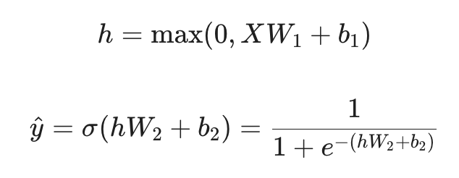
The model was optimized using full-batch Gradient Descent to minimize the Binary Cross-Entropy (BCE) loss:
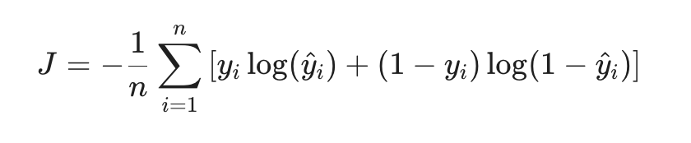
Weight matrices W^1 and W^2 were initialized using a variance-scaling strategy to prevent vanishing gradients, while biases were initializing to zero. The network was been trained over 2,000 epochs with an learning rate of η = 0.05.

ML Results and Interpretation

MLP Predictive Performance:
The custom MLP model demonstrated exceptionally strong predictive capabilities on the unseen test set. The model achieved an overall Accuracy of 93.97%, indicated a high degree of reliability in classifying building vulnerability.
Further evaluation using the Confusion Matrix (figure below, right) reveals a robust balance between sensitivity and precision. The model achieved a Precision of 0.9243 and a Recall of 0.9440, culminating in an F1-Score of 0.9341. In the context of predicting high-risk zones, the high Recall is particularly critical; it indicates a very low rate of False Negatives. Minimizing False Negatives ensures that vulnerable structures are not mistakenly classified as safe, which is paramount for effective municipal planning and risk assessment.
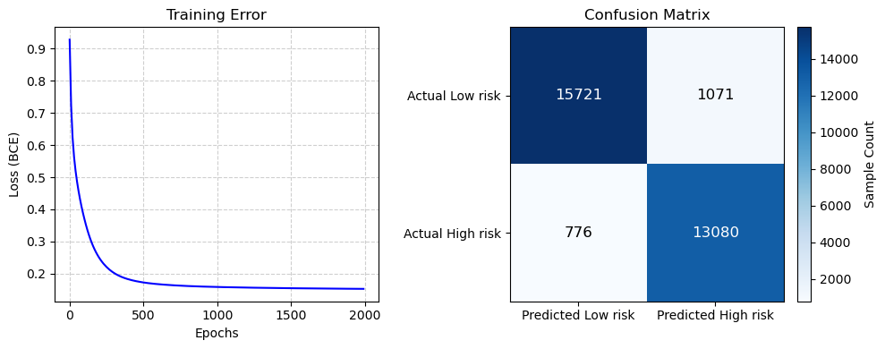
Additionally, the Training Error curve (see figure above, left) illustrates a smooth convergence of the Binary Cross-Entropy loss, dropped very obviously within the first 200 epochs and stabilizing around 0.1533 by the 2000th epoch, confirming that the manual gradient descent implementation effectively optimized the weight parameters without overfitting.

Conclusions and Future Work
MLP: Drawbacks and Model Limitations
While the custom MLP achieved high predictive accuracy, a primary drawback of this approach is its "black-box" nature. So unlike traditional linear or logistic regression models, neural networks does not provide easily interpretable coefficients. Consequently, we can’t directly extract feature importance to determine exactly which structural variables (like ground elevation, foundation height, or building type) act as the primary drivers for flood risk classification…
If this problem were to be expanded in future work, incorporating a post-hoc interpretability framework—such as SHAP (SHapley Additive exPlanations) values—would be highly beneficial to understand the marginal contribution of individual building attributes to the model's predictions!

Appendix: Implementation

MLP:
--------------------------------------------------------------------
def sigmoid(z):
z = np.clip(z, -500, 500)
return 1 / (1 + np.exp(-z))

n = X_train.shape[0]
d = X_train.shape[1]
hidden_nodes = 16
out_nodes = 1
eta = 0.05
epochs = 2000

np.random.seed(33)
W1 = np.random.randn(d, hidden_nodes) * np.sqrt(2.0 / d)
b1 = np.zeros((1, hidden_nodes))
W2 = np.random.randn(hidden_nodes, out_nodes) * np.sqrt(1.0 / hidden_nodes)
b2 = np.zeros((1, out_nodes))
def f(x):
h = np.maximum(0, x.dot(W1) + b1)
return sigmoid(h.dot(W2) + b2)

def compute_bce_loss(Y_true, Y_pred):
epsilon = 1e-8
Y_pred = np.clip(Y_pred, epsilon, 1 - epsilon)
return -np.mean(Y_true * np.log(Y_pred) + (1 - Y_true) * np.log(1 - Y_pred))

errors = []

for epoch in range(epochs):
h = np.maximum(0, X_train.dot(W1) + b1)
y_pred = sigmoid(h.dot(W2) + b2)
dy = y_pred - Y_train
dW2 = h.T.dot(dy) / n
db2 = np.sum(dy, axis=0, keepdims=True) / n
mat1 = np.heaviside(h, 0)
dh = dy.dot(W2.T)

dW1 = X_train.T.dot(dh * mat1) / n
db1 = np.sum(dh * mat1, axis=0, keepdims=True) / n

W2 = W2 - eta * dW2
b2 = b2 - eta * db2
W1 = W1 - eta * dW1
b1 = b1 - eta * db1

if epoch % 10 == 0:
e = compute_bce_loss(Y_train, y_pred)
errors.append(e)
if epoch % 200 == 0:
print(f"Epoch {epoch:<4} | Loss: {e:.4f}")
--------------------------------------------------------------------

